# **Producing Data Visualisation**

## 3.1 Producing data visualisation

#### Introduction

Data visualisation is akin to structural design. Data can be displayed via the following three steps:

* Determining the purpose (the trend, pattern, or vital piece of information you’re trying to communicate briefly)
* Studying the user (how they interact with the data),
* Finally, polishing the data to look as clean and attractive as possible.

This section will explore the general types of data visualisation and ways of producing it in depth.

#### Activity: What is happening in the graph?

****Time****: 10 minutes.

****Purpose****: To analyse a data visualisation.

****Task****: Analyse the graph below and share your analysis of what’s happening in the graph in the discussion forum.

****Feedback****: To help further the conversation, respond to the posts of at least 2 of your peers. You can ask them questions for clarification on their approach or provide them with feedback. Your facilitator will moderate this discussion.

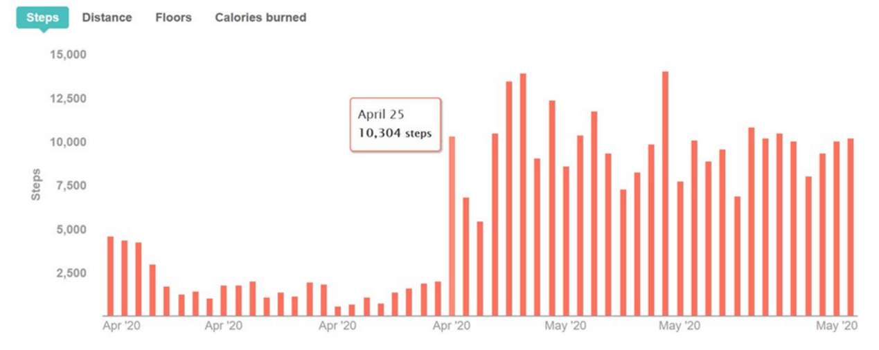

### 3.1.1 How to evaluate and select methods in data visualisation

#### Evaluation and selection of methods in data visualisation

Last week, you explored various methods of data visualisation. Keeping the methods in mind, let’s understand how to evaluate and choose a data visualisation.

Following are a few data visualisation goals that can aid the process of method evaluation:

1. Inform: Convey a significant message or data point that doesn’t require many contexts to understand.
2. Compare: Show parallels or differences among values or parts of a whole.
3. Show Change: Visualise trends over time or space.
4. Organise: Show groups, patterns, rank, or order.
5. Reveal Relationships: Show associations among variables or values.

When visualisation techniques are used, the relevant characteristics of the data, such as data type, dimensionality (number of attributes) and scalability (number of records), are important. The assignments that the user can perform during data exploration also help decide the visualisation technique.

The following figure shows how the characteristics of the data can influence a visualisation technique and establishes the factors to select the best representation of data.

* Standard 1D-3D techniques: These techniques provide graphs to make comparisons and data classifications, determine the correlation between attributes, discover patterns and structures in data, and identify outliers. E.g. box plot or scatter plot.
* Iconographic techniques: These techniques represent each data entry independently, allowing confirmation of rules and behaviour patterns of the data. This is one of the approaches to study the content of the data presented and the meaning of the visuals.
* Geometric techniques: They provide a good overview of the data, giving no significance to represent its attributes and hence outliers may also be detected, characterised by behaviours outside the general standards.
* Pixel-oriented techiniques: They can be used to analyse associations among data attributes to enable the identification of rules and relationships by observing the correlations among them.
* Hierarchical techniques: These techniques are helpful for the use of data arranged in a hierarchical or simple relationship. It is possible to obtain an overview of the data structure and analyse the relationship among the elements, for e.g., with Treemaps.

Here is the table with Data Visualisation Techniques and the methods under it with examples.

|  |  |  |
| --- | --- | --- |
| Techniques | About | Method |
| Charts | These may use axes but not essentially. They use a recognised pattern or theme for displaying data. | * Bubble * Radar * Scatterplot |
| Graphs | These contain an X and Y axis, with at least one showing numerical data. | * Line * Pie * Bar * Histogram |
| Maps | These are used for visualising geospatial, geographic data. | * Choropleth * Cartogram |
| Infographics | These visually display data in an aesthetically pleasing manner and in multiple ways. Often includes other visualisation techniques e.g. graphs. | * Word Cloud |
| Multidimentional | These will have at least two or more dimensions. Often used with other visualisation techniques e.g. chart. | * Pie chart * Heat map |
| Tables | Can display data from a metric set using a tabular view. A table is also known as a data grid or data table. | * Highlight tables & heat maps |

#### Methods for data visualisation

There are two types of visualisations: Static and interactive, and their use depends on the search and analysis at the dimension level. Static visuals can only evaluate data in one dimension, whereas interactive visuals can analyse it in several dimensions.

Let us now explore the four most popular methods used in data visualisation.

1. Bar charts:

Bar charts are one of the most popular ways of visualising data. They present a data set in a quickly identified format that lets viewers recognise highs and lows briefly. They are very versatile, and they are typically used to compare distinct categories, analyse patterns over time, or compare parts of a whole. The three variations on the bar chart are:

|  |  |  |
| --- | --- | --- |
| ****Vertical column**** | ****Horizontal column**** | ****Full stacked column**** |
| Used for chronological data, and it should be in left-to-right format | Used to visualise categories | Used to visualise categories that collectively add up to 100% |
| IMG_256 | IMG_257 | IMG_258 |

Bar graphs are effective if you are:

* Working with longer labels
* Displaying negative numbers
* Comparing 10 or more items

1. Pie charts

Pie charts consist of a circle divided into sectors, each representing a portion of the total. They can be subdivided into no more than five data groups and can be useful for comparing discrete or continuous data.

The two types of pie charts are

1. ****Standard****: Used to exhibit relationships between parts.
2. ****Donut****: An artistic variation that facilitates the inclusion of a total value or a design element in the centre.

These are particularly helpful in digital marketing, as you can use them to show a breakdown of

* Market shares
* Marketing expenditures
* Customer demographics
* Online traffic

1. Bubble charts

A Bubble chart is a multivariable graph cross between a Scatter Plot and a Proportional Area Chart. Bubble charts are typically used to differentiate and demonstrate the relationships between categorised circles, using positioning and proportions. One can use the overall picture of Bubble charts to analyse patterns or correlations.

Like a Scatter Plot, Bubble charts use a Cartesian coordinate system to plot points along a grid where the X and Y axis are separate variables. However, unlike a Scatter Plot, each point is given a label or category (either displayed beside or on a legend).

Each plotted point then signifies a third variable by the area of its circle. Colours can also be used to distinguish between categories or used to represent a supplementary data variable. Time can be shown either by having it as a variable on one axis or by animating the data variables changing over time.

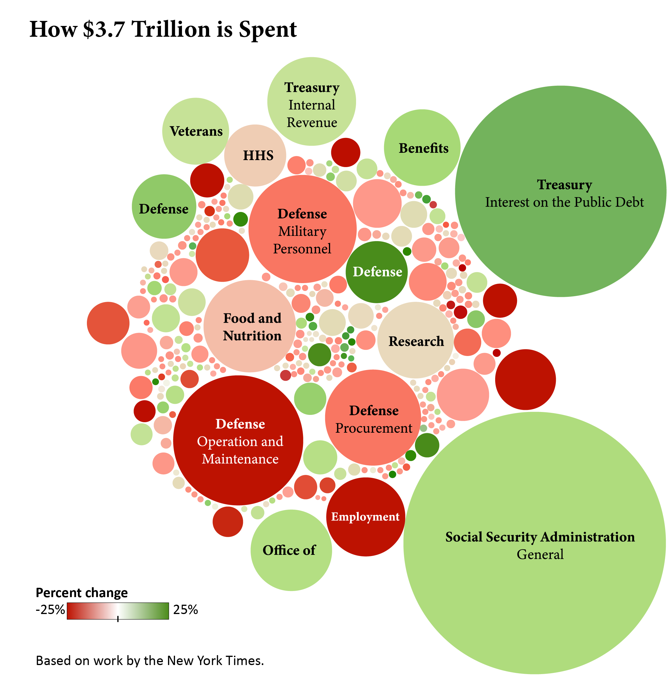

*Source: (The New York Times, 2012)*

1. Choropleth maps

A choropleth map uses colour, shading, and other patterns to visualise numerical values across geographic regions. These visualisations use a movement of colour (or shading) on a range to differentiate high values from low. Choropleth maps allow the audience to see how a variable changes from one region to the next.

A potential drawback to this visualisation is that the exact numerical values aren’t easily available because the colours represent various values. However, some data visualisation tools allow you to add interactivity to the map so the exact values are available.

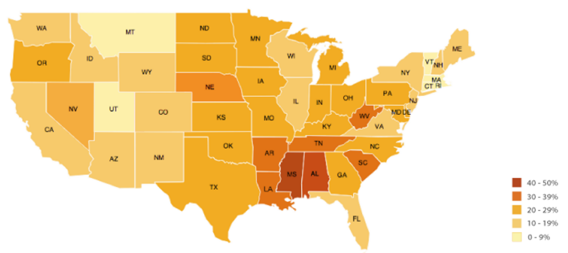

*Source: Choropleth map (Datavizcatalogue, n.d.)*

The following 5-minute 36-second video shows you the cultural mobility map, created by a team of historians and scientists who tracked the births and deaths of notable individuals from 600 BC to the present day. Using these thought leaders as a proxy for skills and ideas, their data reveals intellectual hotspots and tracks the rise and fall of empires.

[https://youtu.be/4gIhRkCcD4U](https://youtu.be/4gIhRkCcD4U" \o "Share link" \t "https://www.youtube.com/embed/_blank) *Source: ([nature video](https://www.youtube.com/@NatureVideoChannel" \t "https://elearn.sunway.edu.my/webapps/blackboard/execute/_blank), 2014)*

Refer to the following reading to further your understanding about the types of visualisations.

* Ribecca, S. The Data Visualisation Catalogue. Retrieved February 22, 2022, from Datavizcatalogue. [https://datavizcatalogue.com/index.html](https://datavizcatalogue.com/index.html" \t "https://elearn.sunway.edu.my/webapps/blackboard/execute/_blank)

The following reading can help determine how to choose the right data visualisation.

* Yi, M., Restori, M. How to Choose the Right Data Visualization. Retrieved February 22, 2022 from Chartio. [https://chartio.com/learn/charts/how-to-choose-data-visualization/](https://chartio.com/learn/charts/how-to-choose-data-visualization/" \t "https://elearn.sunway.edu.my/webapps/blackboard/execute/_blank)

### 3.1.2 Highlight tables

#### Activity: Tableau charts - Highlight tables

****Time****: 25 minutes

****Purpose****: To create a highlight table in Tableau

****Task****: Highlight tables are used to compare categorical data using colour. Just like the name suggests, highlight tables add colour highlights for users to read the table more naturally and effectively.

****Feedback****: To help further the conversation, respond to the posts of at least 2 of your peers. You can ask them questions for clarification on their approach or provide them with feedback. Your facilitator will moderate this discussion.

##### **Instructions**

1. Create a highlight table to explore how Profit varies across product Sub-Categories for different Regions.

2. Connect to Superstores data sets pre-loaded in the Tableau Desktop app.

3. Drag the dimension field Sub-category (use filter to list the Dimensions) to the Rows shelf.

4. Drag dimension field Region to the Columns shelf.

5. Drag measure field Profit to the Label tab under Marks cards.

6. See the resulting Highlight table below:

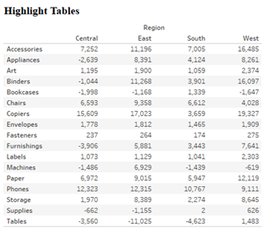

7. Next,

     a. Select 'Highlight tables' under the Show Me tab.

     b. Add some formatting and colour adjustments you like.

8. Show the most profitable Sub-category, Phones in the West Region.

9. Show the Unprofitable Sub-category in the East region.

10. Add more statistics like grand totals can also be added by going to

Analysis menu >>Totals >> Show Row Grand Totals or Show Column Grand Totals.

## 3.2 Pre-attentive attributes

#### Introduction

Pre-attentive processing occurs without our awareness at an extremely high speed. It is tuned to detect a specific set of visual attributes called Pre-attentive Attributes.

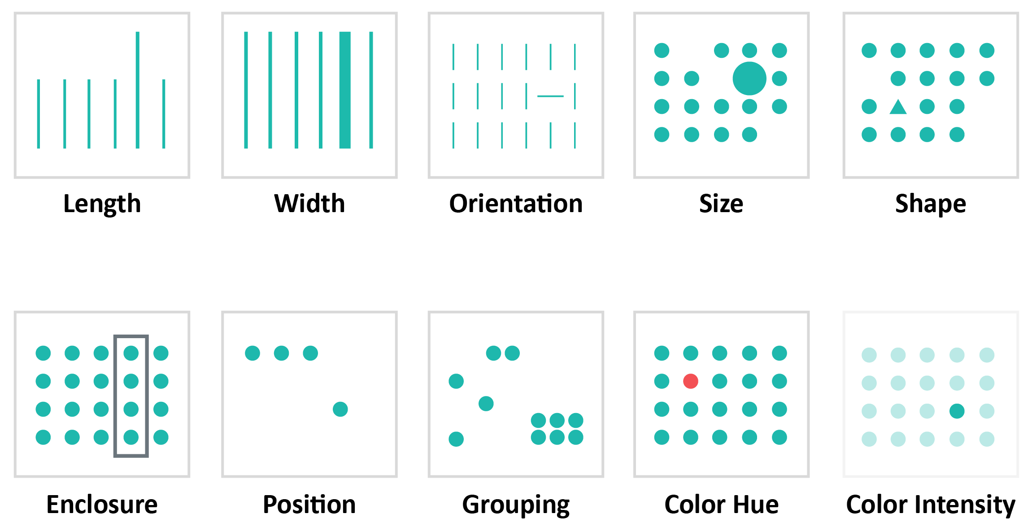

*Source: Visual properties (Mede Analytics, 2021)*

Let us refresh our understanding of visual perception before exploring pre-attentive attributes at length. Click on the two tabs below to learn more.

1. **What is visual perception?**

Approximately 30 separate processes, each designed to perceive a different characteristic of objects that we see in the world (position, size, shape, colour, angle, etc.), occur simultaneously in the visual cortex. It is from these individual pre-attentive attributes of perception that the objects that we see with our eyes are constructed as images in our mind’s eye. This is known as visual perception. (Few, 2016)

1. **How does visual perception affect data visualisation?**

The main purpose of data visualisation is to aid a good judgement. To make good decisions, we need to understand trends, patterns, and relationships from a picture known as gaining insights from data. The complicated part is, we don’t see images with our eyes; we see them with our brains. The knowledge of visual perception is in fact what goes on inside our minds when we see a visual.

#### What are pre-attentive attributes?

**Pre-attentive attributes – Its categories and importance**

Pre-attentive attributes decide which information catches our attention. This is important in visualisation because it directs the viewer’s attention to the most critical part of the information.

Pre-attentive attributes are visual elements that facilitate rapid visual perception in any space. Designers use these characteristics to uncover relevant information and present it to the user/audience.

****There are four categories of pre-attentives visual attributes****:

* Colour (intensity, hue)
* Form (orientation, line length, line width, size, shape, curvature, enclosure, added marks)
* Spatial Positioning (2-D position)
* Movement

Pre-attentive attributes are visual elements that we see without using intentional effort. Pre-attentive processes occur within 200ms after exposure to a visual stimulus and do not require sequential search.

#### The importance of pre-attentive attributes like size, colour, and position on the dashboard

Every chart you build in Tableau, or any other data visualisation tool uses pre-attentive attributes, but you must make design choices to use them decisively. Here are a few quick examples.

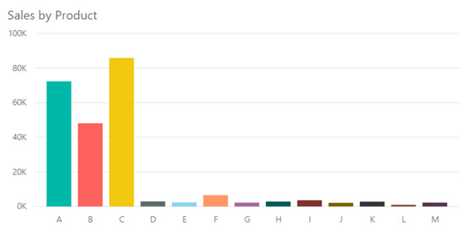

*Source: Tableau Desktop (Sunway, 2022)*

The chart above uses a distinct colour for each bar and orders the bars alphabetically by product. Notice how your eyes move between the colours in the chart.

*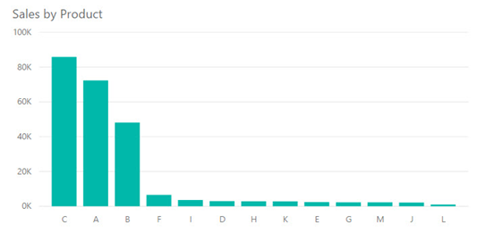*

*Source: Tableau Desktop (Sunway, 2022)*

This chart uses a single colour across all bars and orders the bars descending by sales amount. When observing the chart, your eyes easily follow the bars' length down and across the categories from largest to smallest.

Additional example:

|  |  |  |
| --- | --- | --- |
| *Picture12* | *Picture13* | *Picture14* |

The vertical bar chart in Figure C has a dark black border, which is the first thing you notice about the chart. Once we remove the border, as shown in the chart Figure D, we notice that the chart category labels have a diagonal direction. They stand out because nothing else in the chart is diagonal. It is slightly confusing and difficult to read. The horizontal bar chart in Figure E shows the same information in the same order. Still, it allows the category labels to remain horizontal, allowing our eyes to focus on the information encoded by the bars.

Therefore, we can use pre-attentive attributes to highlight the most important parts of a visual. Colour is the most powerful pre-attentive attribute we have, so we should use it strategically.

#### Visualisation elements

Let us now explore each visualisation element in depth.

1. Colour

Colour is a strong attribute in data visualisation. In a good visualisation, it can spotlight attention and provide clarity. When colour is used badly, it can create confusion. A colour palette is simply a collection of colours applied to the visual elements in your report. What we typically refer to as colour is a combination of three main properties: hue (base colour on the colour wheel), intensity (brightness or greyness) and value (lightness or darkness).

You can build an engaging and expert looking report with just six colours.

* ****Main colour**** - default colour on graphs
* ****Colour 2**** - used when multiple colours are needed in a graph or report
* ****Colour 3**** - used when multiple colours are needed in a graph or report and Colour 2 has already been used
* ****Highlight colour**** - a colour used to highlight important data points to make them stand out from other points on the page
* ****Border colour**** - a light colour used for borders on tables and KPIs where necessary
* ****Title colour**** - colour used for visual titles and axis labels as appropriate

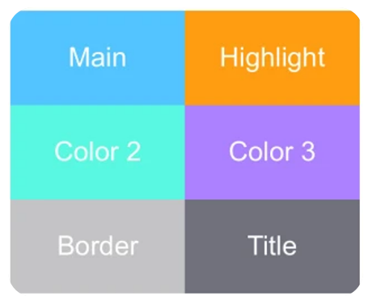

*Source: Colour palette (Sunway University, 2022)*

1. Grouping

Grouping refers to an event when fundamental data is collected into individual data points, such as hourly vs. daily vs. weekly. In data storytelling, it’s important to define the differences to understand the audience. Reducing the unnecessary differences will allow you to focus the design on the necessary differences.

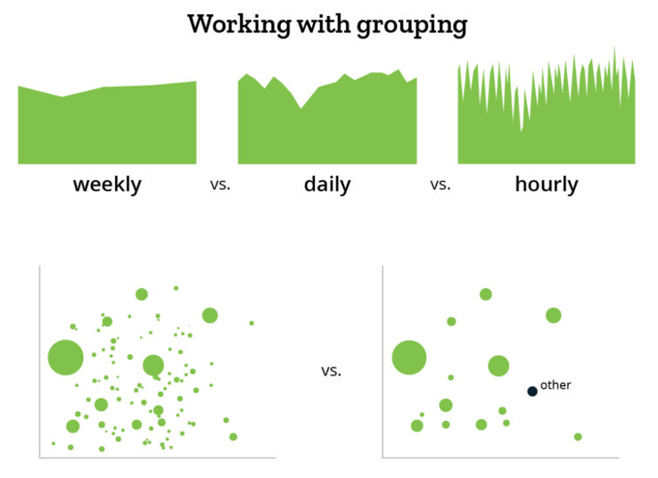

*Source: Grouping (Mede Analytics, 2021)*

1. Size

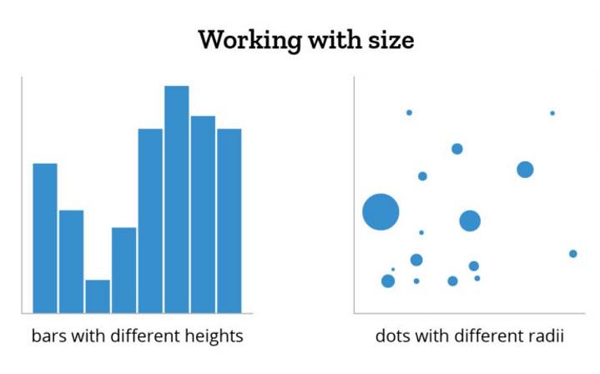

*Source: Size (Mede Analytics, 2021)*

Size as a visualisation element transcends representing quantities of measurement: people, currency, orders, clicks and more. If you’re comparing data that is not quantitative, a different design element may be used for distinguishing and comparing values.

When working with size, it’s critical to maintain true proportions. If you change the y-axis of a bar chart to start at 100 instead of 0, you will interfere with the proportion of the bars. Essentially, a bar taking up twice as much space would no longer represent twice as much stuff. When using circles, you can’t simply double the width to represent double the value, since it would quadruple the area of the circle. Instead, ensure the comparative sizes of the data points conserve the true dimensions of the values they represent so the user can correctly compare them.

1. Position

Once you know which data to show and how small/big it should be characterised, the next step is deciding where those data points should go. Positioning can be used in many ways. Bars can be placed in sequential order in a bar chart to represent time. In a scatterplot, the placement of a data point along the x- and y-axes can be useful in relating points. The distance between data points is important: if two data points are near each other, they are related somehow.

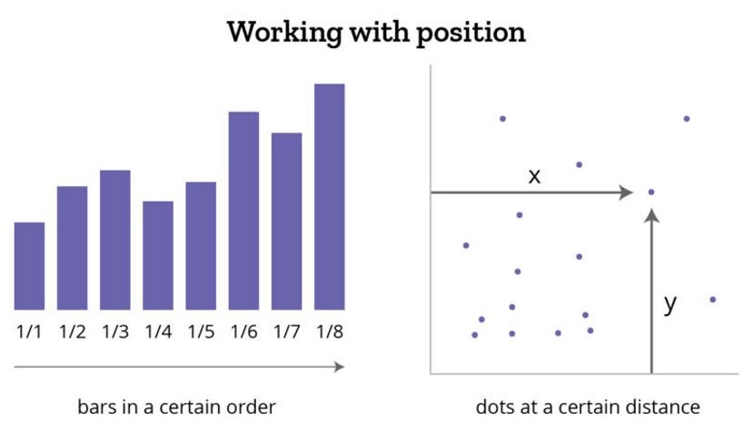

*Source: Position (Mede Analytics, 2021)*

Position is very important when creating a dashboard of various data charts/widgets/information. Most users equate importance to the position on the dashboard with the top left corner being interpreted as most important. Thus, the position isn’t just important within an individual data visualisation but also encompasses the placement of a chart within a dashboard of information.

#### Using pre-eattentive attributes strategically

The following seven points highlight using pre-attentive attributes in a strategic manner:

1. Restrict the use of bright colours for elements that need attention from viewers or those that should be analysed first and use less strong colours for other items.
2. Don’t use several colours unnecessarily. For example, a bar chart with only one field on the categorical axis does not need separate colours for each bar.
3. Don’t use rotated axis labels if they don’t fit horizontally. Truncate categories and numbers or change to a different chart type that supports longer labels.
4. Start bar charts at 0 to allow viewers to accurately judge the length and distinguish between bars.
5. Make sure visuals in a row are well aligned. If it isn’t, it can be distracting.
6. The chart title should be the least obvious element in your visualisation. Whereas, data in your charts, KPIs, and cards should draw the most attention.
7. Try using whitespace to separate charts rather than adding dark and intense borders.

The following 4-minute 35-second video is recommended to help you analyse and apply essential design principles to your Tableau visualisations. [https://youtu.be/uxfUgdReL-w](https://youtu.be/uxfUgdReL-w" \o "Share link" \t "https://www.youtube.com/embed/_blank) *Source: ([Tera Lorette](https://www.youtube.com/@teralorette5305" \t "https://elearn.sunway.edu.my/webapps/blackboard/execute/_blank), 2020)*

The following reading sheds more light on pre-attentive visual properties and how to use them in information visualisation.

* Interaction Design Foundation. (2019). *Pre-attentive Visual Properties and How to Use Them in Information Visualization*. Interaction Design Organisation.  
  [https://www.interaction-design.org/literature/article/preattentive-visual-properties-and-how-to-use-them-in-information-visualization](https://www.interaction-design.org/literature/article/preattentive-visual-properties-and-how-to-use-them-in-information-visualization" \t "https://elearn.sunway.edu.my/webapps/blackboard/execute/_blank)

The following reading serves as a good practice to learn how to declutter your graphs.

* Knaflic, C.N. (2017). *declutter this graph!* Storytelling with data. [https://www.storytellingwithdata.com/blog/2017/3/29/declutter-this-graph](https://www.storytellingwithdata.com/blog/2017/3/29/declutter-this-graph" \t "https://elearn.sunway.edu.my/webapps/blackboard/execute/_blank)

### 3.2.1 Can you differentiate between good and bad data?

#### Activity: Good and bad data visualisation

****Time****: 25 minutes

****Purpose****: To differentiate between good and bad data visualisation

****Task****: Answer two primary questions for the given examples.

****Feedback****: To help further the conversation, respond to the posts of at least 2 of your peers. You can ask them questions for clarification on their approach or provide them with feedback. Your facilitator will moderate this discussion.

**Instructions**

1. Describe the graph and explain if this is a bad or good example of data visualisation. Justify your answer.
2. Describe the pre-attentive attributes the chart makers need to consider when creating this type of chart.

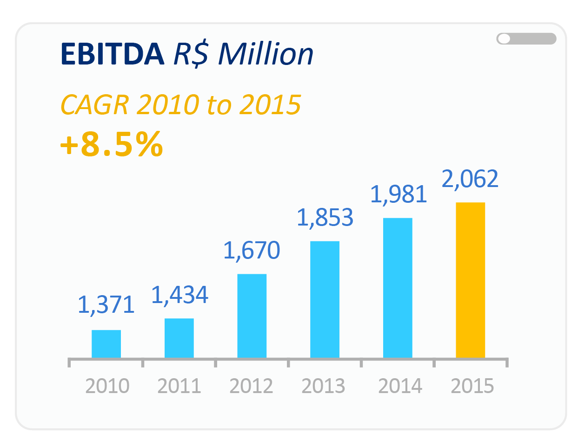

Source: EBITDA (Toptal, n.d.)

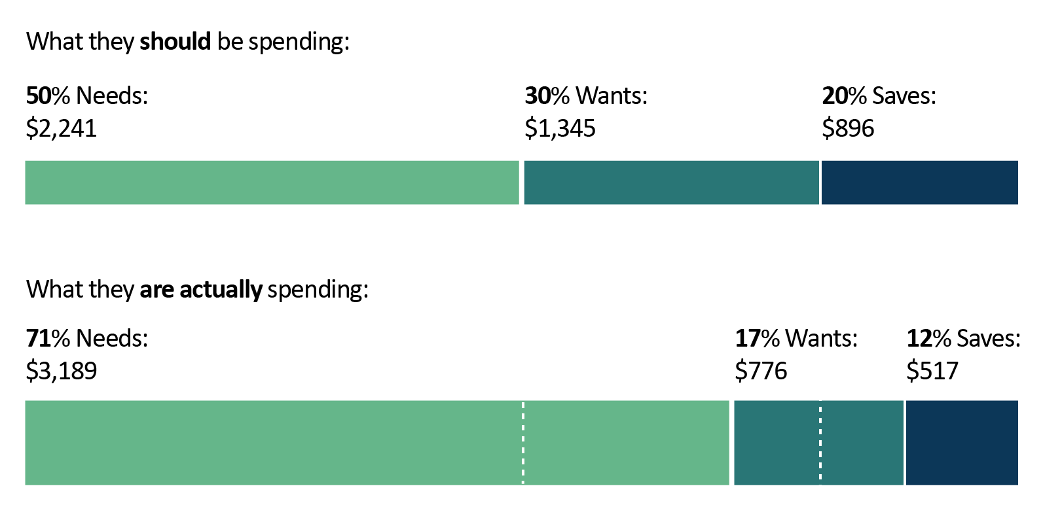

Source: Spending data (Fiftythirtytwenty, n.d.)

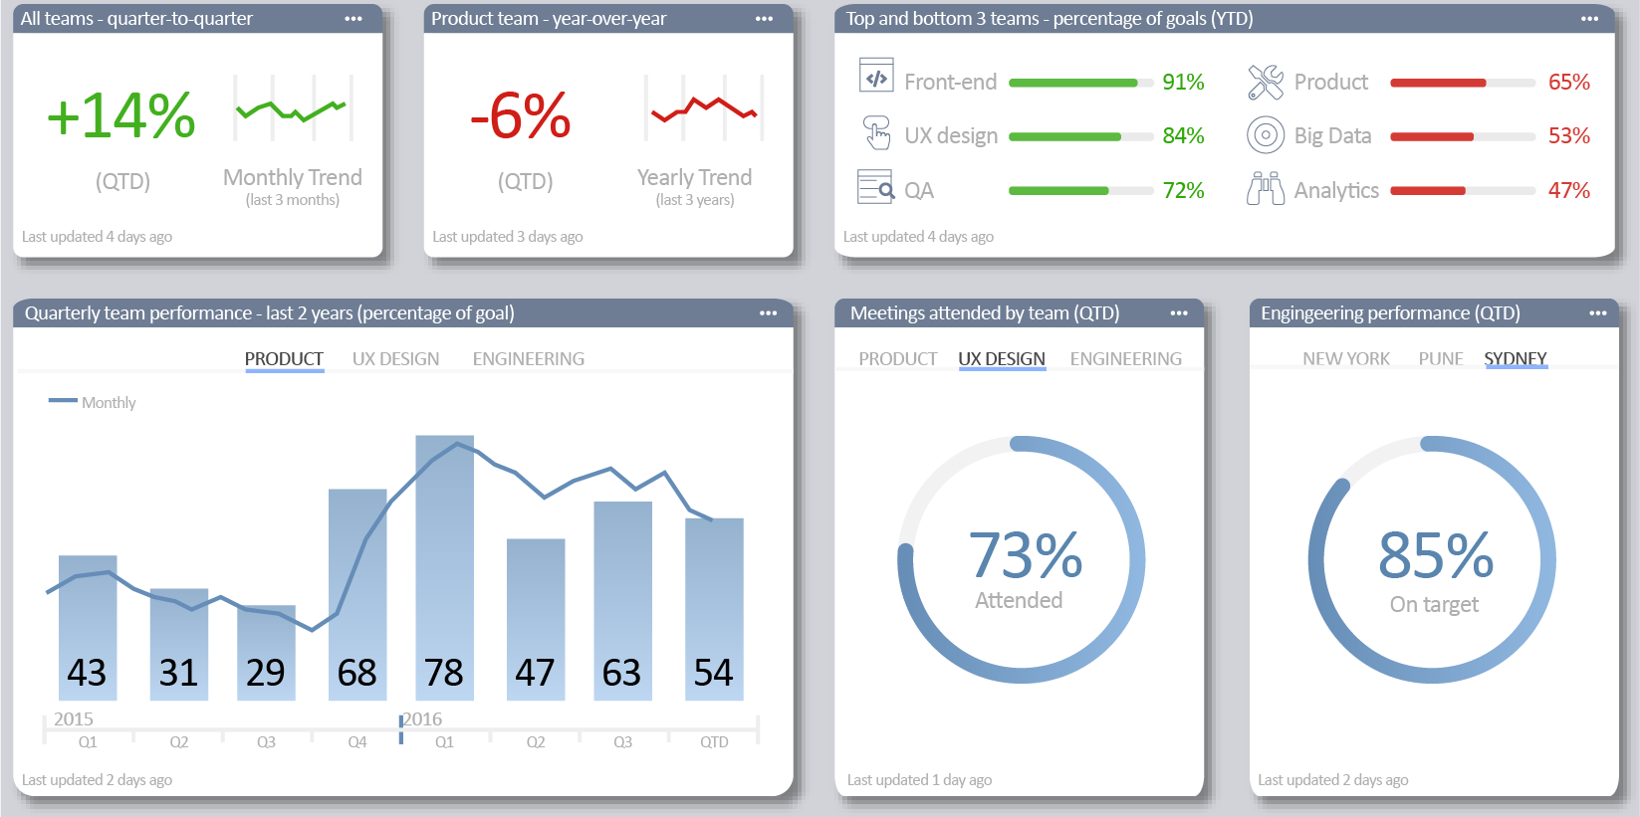

Source: Data visualisation (Toptal, n.d.)

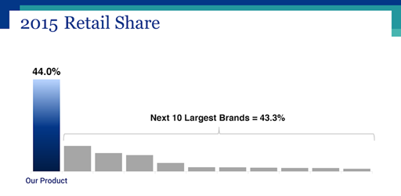

*Source: Retail store data (Toptal, n.d.)*

## 3.3 Visual hierarchy and colour

#### Introduction

Visual hierarchy is the order that the human eye follows when recognising what it observes. Given a field of perception, the visual contrast between forms creates the order in question. The human mind begins by identifying the objects with the highest contrast compared with their environment.

#### Activity: Spot the use of pre-attentive attributes in the infographic

Observe the infographic and list two features that make it attractive and interesting. Add them to the wordcloud below.

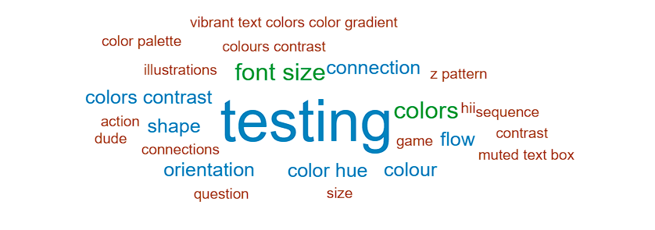

The Infographic:

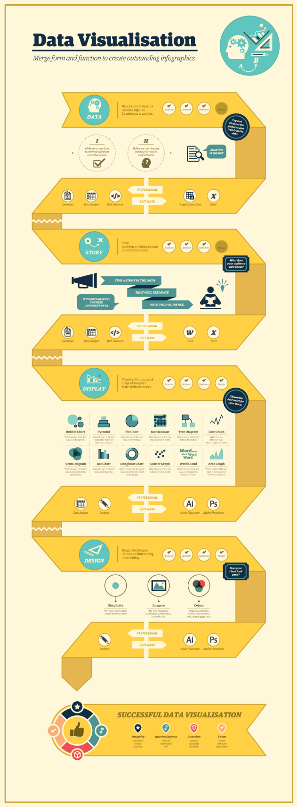

#### The use of hierarchy in data visualisation

**Explore: Principles of visual hierarchy and its strategic use**

An experienced designer/visualiser should have a reasonable knowledge of the human eyes’ inherent tendencies. Rather than seeing chunks of data, the eye pictorially sees the information. Therefore, children’s books contain more pictures and words with a large print. Similarly, visuals take centre stage in telling the story in comic books, and texts only serve as an accessory. This results in easy-to-read content which is faster to digest for the human brain. Designers must have a keen eye on organising content, to control viewers’ eyes so that information of paramount importance is seen first.

There are two common patterns in which the human eye will scan and read a page or a visual — the ****Z pattern**** and the ****F pattern****.

**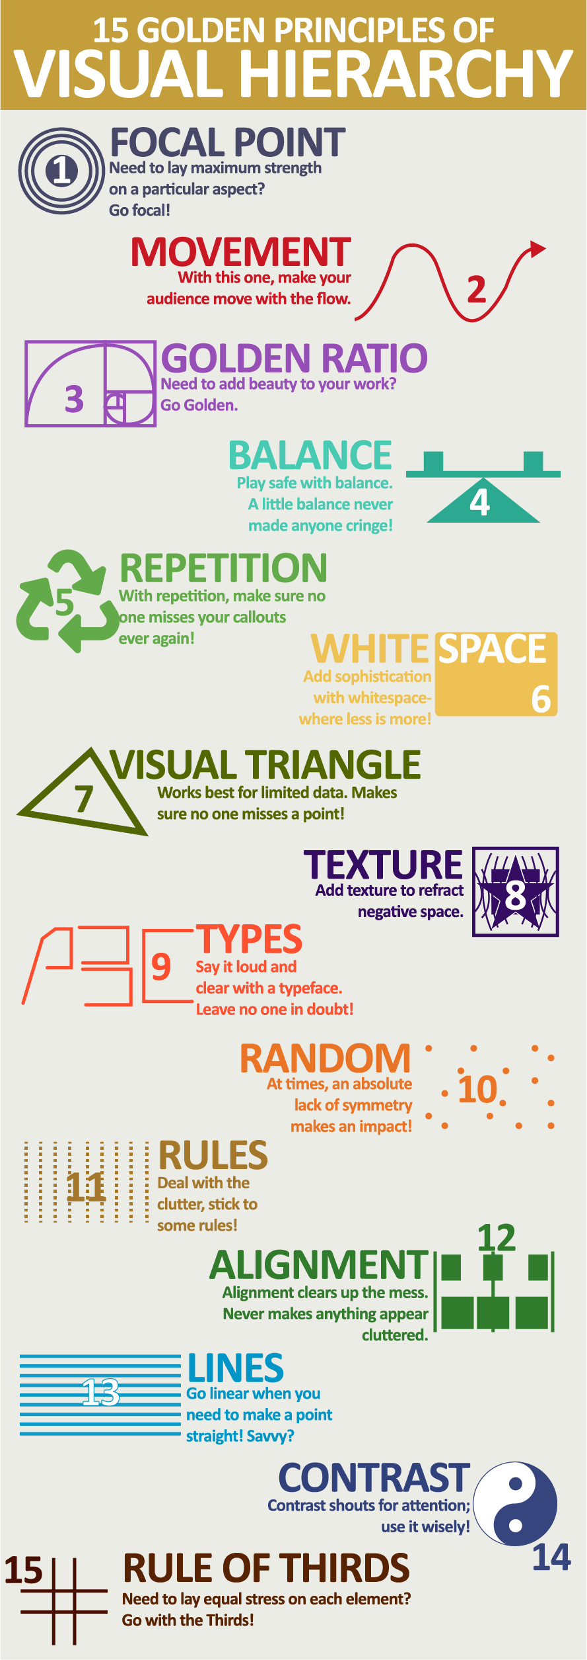Z-pattern**

This is most used when there is a low level of text content. To maximise the use of this pattern, the designer can place the most important content within the Z shape. Users would scan the page from top left to top right, move through the content, going to the bottom left to the bottom right.

1. **Pattern**

This is usually utilised for text-heavy content or video content. Viewers would begin scanning the page from top left to top right, then keep going down from left side to the right side of the page, continually, looking for visual elements that would help them understand the written content and this continues until they reach the bottom of the page.

#### Hierarchy principles

Irrespective of the pattern you choose; it is important to know the intricacies of emphasising the elements on top of the hierarchy list. Intricacies such as size, colours, shapes, or the information to be included and excluded affect the design hierarchy. In design, especially data visualisation, all aspects cannot be highlighted. For an element to stand out, others must recede into the backdrop.

1. Size:

Like a newspaper headline, the larger the component, the more it will attract attention. The more attention it attracts, the more viewers will relate to it because it’s the first thing they see.

1. Colour: As mentioned earlier, different colours have different psychological links and affect viewers’ perception of the objects. Bright colours are naturally more attention-grabbing, followed by rich darker colours and lighter tints. Muted, subdued colours lay at the bottom of the colour hierarchy.
2. Layout & Alignment: Layout and alignment play a key role in highlighting the importance.
3. Repetition: Repeating styles convey to the viewer that it is a unit. A good example is the use of hyperlinks. Links are usually underlined, highlighting that it is clickable.
4. Proximity / spacing: The placement of design elements tells users how likely they are to be related. For instance, this list has a header/title, and each of the points is separated by a row of whitespace. This proximity or distance shows that those list items are separate but unrelated to each other.
5. Texture & Style: Using various styles and textures can help visually expand the content hierarchy. Using distinct fonts in a project, or textured backgrounds that compete with each other can lead users’ eyes to the most assertive elements.
6. Contrast: Contrast refers to the value difference between colours. The darkest contrast you could make between the two colours is black and white. Strong contrast can highlight important elements, while weak contrast will mix elements. Strong contrast might be eye-catching and needed to establish hierarchy, but in turn, weak contrast is less challenging and can be used to create a more pleasant design that users enjoy.

#### Building blocks of visual hierarchy

Hierarchy is a visual design principle that designers use to show the importance of each page/screen’s contents by manipulating the following characteristics: Click on the 7 tabs below to learn more.

1. Scale

****Scale**** - Users notice bigger elements more easily

* Larger elements will appear to be more important
* Making word/phrase/graphic/photo big and bold will draw the viewer's attention and generate hierarchy
* Complement this with small elements based on your design



Source: Scale (Learn Hub, n.d.)

1. Colour

****Colour****- Bright colours typically attract more attention than muted ones.

* More contrast will grab attention first
* Sharp contrast where you want attention first
* Lower contrast for lesser importation elements

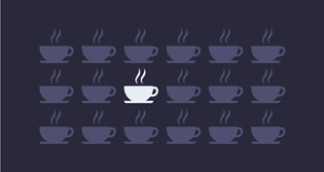

*Source: Color visual hierarchy (Digital Impact &, 2021)*

1. Position / Alignment

****Position/Alignment**** - Non-aligned elements stand out over aligned ones.

* Position/Alignment connects elements and helps create structure
* Use visual hierarchy by taking something out of the structure
* Make it stand out in a different position

1. Repetition: Repeating styles can suggest content is related
2. Proximity: Closely placed elements seems related
3. Whitespace: More space around elements draws the eye towards them
4. Texture & Style:Richer textures stand out over flat ones

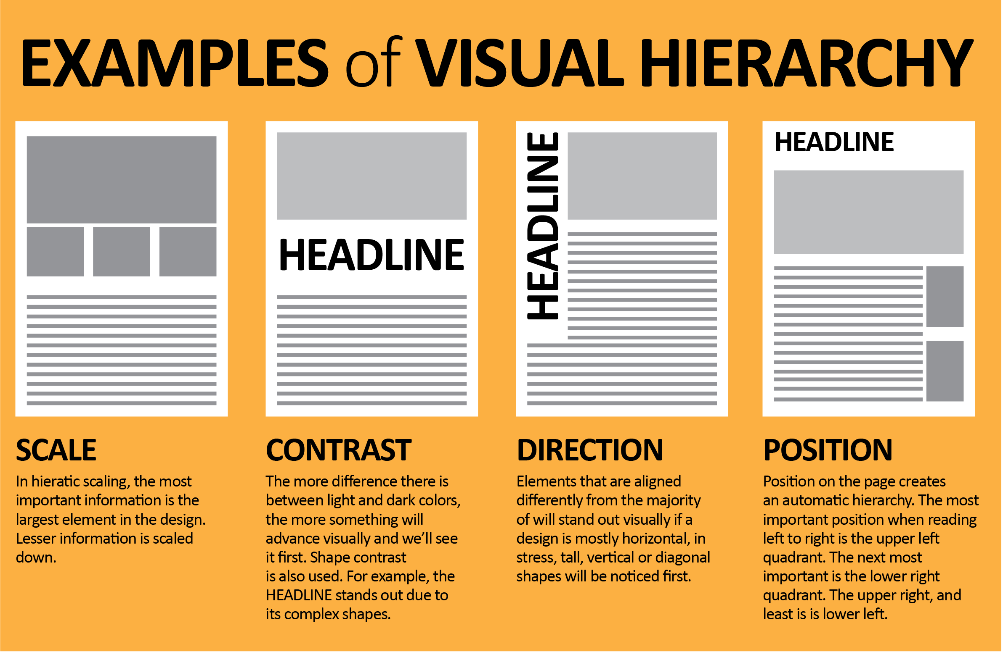

*Source: Visual hierarchy (Alvalyn, 2019)*

#### Colour as a strategic tool

In many cases, the most obvious preattentive attribute in data visualisations is the use of colour. Colour may be used in one of three primary ways:

1. Sequencial colour

Sequential colour is the use of a single colour from light to dark. Population density may be effectively distinguished in this manner. In the graph below, you can see comparative differences in unemployment rates.

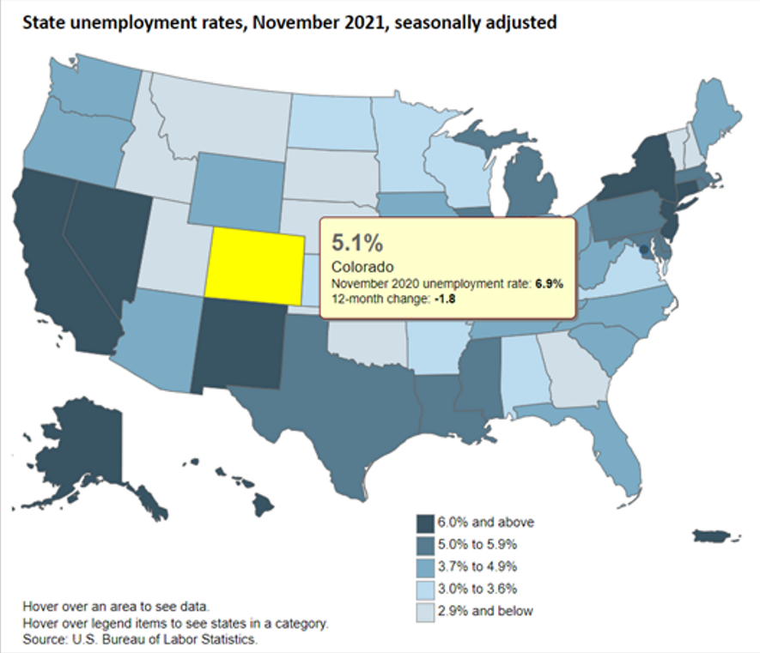

*Source: State unemployment rates map (U.S. BUREAU OF LABOR STATISTICS, n.d.)*

1. Diverging colour

Diverging colour is used to show a range diverging from a midpoint, like sequential, but can be used to convert two different ranges such as positive and negative.

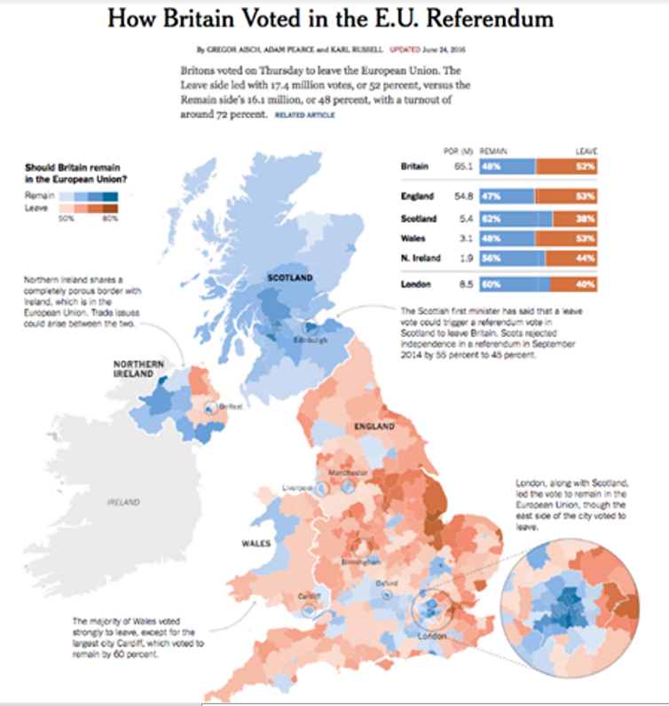

*Source: How Britain voted in the E.U. Referendum (Krum, 2016)*

1. Categorical colour

Categorical colour uses different colour hues to distinguish between different categories.

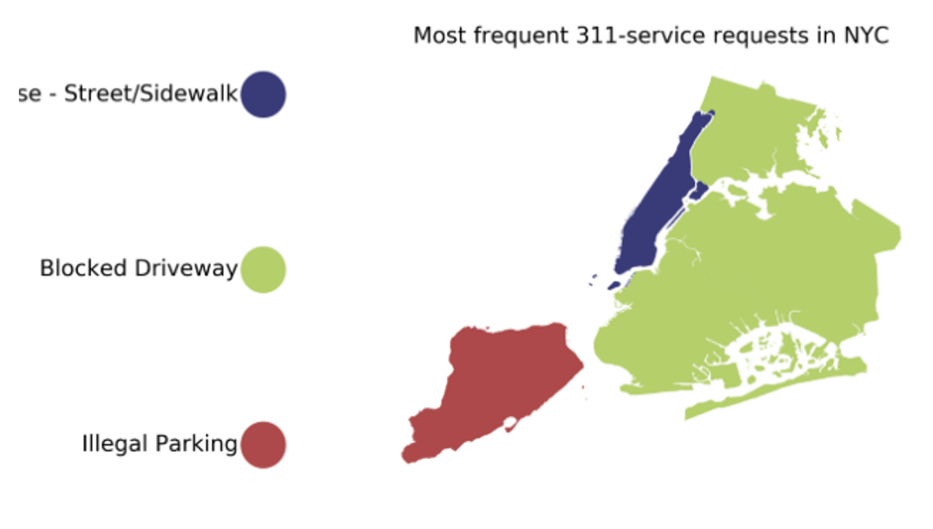

*Source: Map from categorical data, built with Python (nycopendata, n.d.)*

*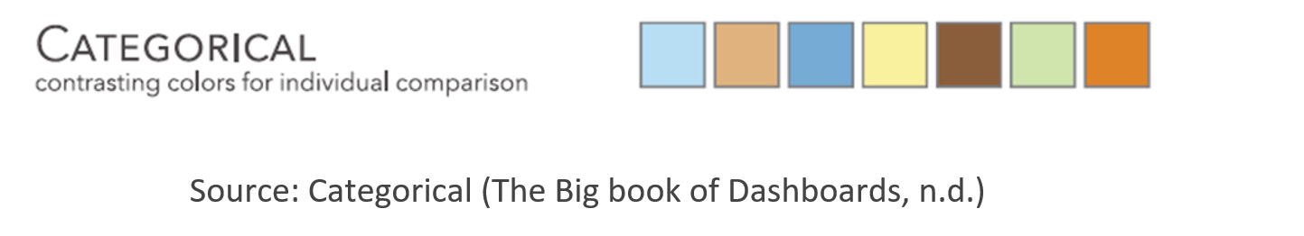*

*Source: Categorical (The Big book of Dashboards, n.d.)*

*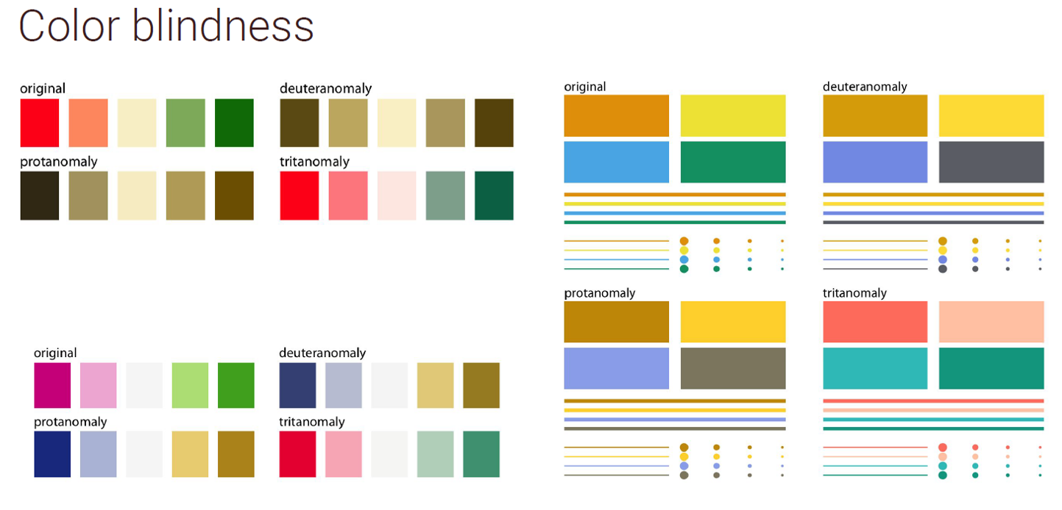*

*Source: Design Principles for Visualization (Tanugi, n.d.)*

Colour blindness (or colour vision deficiency, or CVD) affects about 8 percent of men and 0.5 percent of women.

The most common type is red/green colorblindness. It makes it hard to read colour coded information, such as used in data visualisations.

Source: National Eye Institute. (2019). Color Blindness. National Eye Institute. <https://www.nei.nih.gov/learn-about-eye-health/eye-conditions-and-diseases/color-blindness>)

[ColorBrewer](https://colorbrewer2.org/" \l "type=sequential&scheme=BuGn&n=3" \t "https://elearn.sunway.edu.my/webapps/blackboard/execute/_blank) includes tools to help choose colour blind safe colours.

The following reading emphasises on a few practical rules for using colour in charts.

* Few, S. (2008). Practical Rules for Using Color in Charts. *Perceptual Edge Visual Business Intelligence Newsletter*. [http://www.perceptualedge.com/articles/visual\_business\_intelligence/rules\_for\_using\_color.pdf](http://www.perceptualedge.com/articles/visual_business_intelligence/rules_for_using_color.pdf" \t "https://elearn.sunway.edu.my/webapps/blackboard/execute/_blank)

Refer to the following reading to understand the role of colour theory in data visualisation.

* RevUnit. (2022). *The Role of Color Theory in Data Visualization*.  RevUnit. [https://www.revunit.com/post/the-role-of-color-theory-in-data-visualization](https://www.revunit.com/post/the-role-of-color-theory-in-data-visualization" \t "https://elearn.sunway.edu.my/webapps/blackboard/execute/_blank)

### 3.3.1 Principles of visual hierarchy and colour palette

#### Activity: Application of principles of visual hierarchy and colour palette

****Time****: 20 minutes

****Purpose****: To understand the applications of principles of visual hierarchy and colour applied in popular data visualisation

****Task****: Follow the steps below and answer all activity questions in the discussion forum

****Feedback****: To help further the conversation, respond to the posts of at least 2 of your peers. You can ask them questions for clarification on their approach or provide them with feedback. Your facilitator will moderate this discussion.

**Instructions**

1. Find a data visualisation that interests you from Tableau Viz of the Day.
2. Paste it into a Google doc. Please write your names above the figure.
3. Answer the following questions:
   1. What is the most obvious point made by the figure?
   2. Discuss any additional points you observed upon further investigation.
   3. What did you like about this presentation of the data? i.e., what about this figure works well for making the point for visual hierarchy and use of colour palette.
4. How could the data have been presented more clearly? Did you find any misleading elements? Colour choices? Distracting sizes, alignments, or any other attributes?

### 3.3.2 Activity: Design a visualisation for a small data set and provide a precise rationale for your design choices

#### Activity: Design a visualisation for a small data set and provide a precise rationale for your design choices

****Time****: 45 minutes

****Purpose****: To understand the problem statement and design a visualisation for the same

****Task****: In this application activity, you will design a visualisation for a small data set of your choice and provide a rigorous rationale for your design choices. You should in theory be ready to explain the contribution of the visualisation for the intended audience. You are free to use any graphics or charting tools. Follow the steps given and share your outputs in the discussion forum

****Feedback****: A standalone PDF with the graphic exported and notes can be submitted through forum/page. To help further the conversation, respond to the posts of at least 2 of your peers. You can ask them questions for clarification on their approach or provide them with feedback. Your facilitator will moderate this discussion

**Instructions**

1. Start by choosing a question you would like the visualisation to answer.
2. Design a static visualisation (i.e., a single image) that you believe efficiently answers that question and use the question as the title of your graphic.
3. Describe your design briefly in not more than two paragraphs.

Document the visual encodings you used and why they are appropriate for the data and your specific question. These decisions include the choice of visualisation type, size, colour, scale, and other visual elements, as well as the use of sorting or other data transformations. How do these decisions facilitate effective communication?

Recommended data sources:

1. IPUMS <https://www.ipums.org/>
2. 43 Free Datasets for Building an Irresistible Portfolio (2023) <https://www.dataquest.io/blog/free-datasets-for-projects/>

Tip - For the data, find a few numbers relating to a topic that interests you. For example, the top five fortune 500 companies or top five growing economies in the world. Be creative.